

**YEAR**

**Brisbane Adventist College**

**2021**

**STUDENT NAME: Johnny Dieckmann**

**Subject:** Digital Technologies

**Teacher: Mr Jamin Henley**

**Draft Due Date:** 18 February 2021

**Final Due Date: 25 February 2021**

|  |  |  |  |
| --- | --- | --- | --- |
| **Year Level** | Year 9 | **Semester** | 1 |
| **Task Number** | Task 1 | **Task Type** | Digital Project |
| **Task Authorship** | Individual Task (unique task submitted from each student) | | |
| **Task Title** | HTML Project | | |

|  |
| --- |
| **Task Description / Instructions to Students** |
| You will use your HTML skills to plan and build a website about a topic of your choice. Once you have built your site you will host both your site and html files on GitHub. Your website will have three pages: Home (index.html) and two other pages of your choice. Your pages should include a variety of elements such as lists, tables, images etc. Ideally you will use responsive web design so that your website will display correctly on different devices. You will upload your planning documentation along with your website files in a zipped folder to SEQTA. There are further instructions about how to plan and build your website on the following pages. |
| **Conditions / Submission Expectations** |
| * 3 weeks’ notice * Project to be completed in class time (you may also work on this at home if needed) * You may also seek assistance from your teacher. You may also use w3schools and other websites to find solutions to problems that arise. * Plan what you want your website to look like (sketch this). Note the features of the website that are necessary for it to function as intended and those that improve the user experience because of how it looks. * You must reference information by linking to the site where you found it. * You need to fill in the project log each day that you work on this task.   You will upload your planning, managing and evaluation documentation along with your website files in a zipped folder to SEQTA. |

**Website Structure**

A website consists of many files: text content, code, stylesheets, media content, and so on. When you're building a website, you need to assemble these files into a sensible structure on your local computer, make sure they can talk to one another, and get all your content looking right, before you eventually upload them to a server.

When you are building your website the file structure should look something like this:

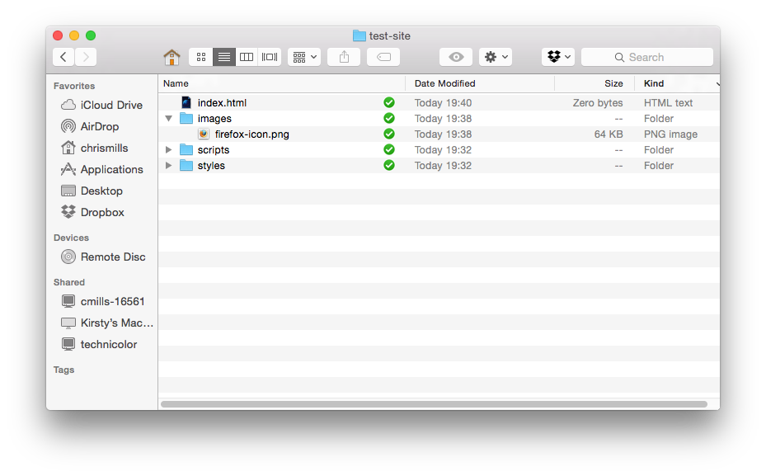

[This website](https://developer.mozilla.org/en-US/docs/Learn/Getting_started_with_the_web/Dealing_with_files) has information on how to link to each of your pages. This is very important as you will do this to create a menu.

Include your planning and management documentation in your main website folder.

**Planning**

Name of website: Nintendo Collectables Shop

Topic of website: Online shop to buy old/classic/limited edition Nintendo items

Content Data and Presentation

How will the content data of your website be kept separate from the presentation and why?

There will be a header at the top of the page that stays in position when scrolling. The content will appear underneath the header.

Functional requirements

Which features of the website are necessary for it to function as intended?

* Links between websites

Non-Functional requirements

Which features of the website make it look visually pleasing but are not needed for it to function?

Sketch a design of your website. Include:

* Layout
* Colour scheme (background, menu, tables etc.)
* Annotations of fonts (colour, style, size etc.)

This is included in the submission, in “site-files/scripts/bar.js”.

**Managing**

|  |  |  |  |
| --- | --- | --- | --- |
| Project Name: | DT Assignment | | |
| Begin Date: | 9th Feb | Target End Date: | 9th Mar |

Project Log

|  |  |  |  |  |  |
| --- | --- | --- | --- | --- | --- |
| Scheduled | | Actual | | Task Action List | Initial |
| Begin | End | Begin | End |
| 9th Feb | 9th Mar | 9th Feb | 9th Mar | DT Assignment | JD |
|  |  |  |  |  |  |
|  |  |  |  |  |  |
|  |  |  |  |  |  |
|  |  |  |  |  |  |
|  |  |  |  |  |  |
|  |  |  |  |  |  |
|  |  |  |  |  |  |
|  |  |  |  |  |  |
|  |  |  |  |  |  |
|  |  |  |  |  |  |
|  |  |  |  |  |  |
|  |  |  |  |  |  |
|  |  |  |  |  |  |
|  |  |  |  |  |  |
|  |  |  |  |  |  |
|  |  |  |  |  |  |
|  |  |  |  |  |  |
|  |  |  |  |  |  |
|  |  |  |  |  |  |
|  |  |  |  |  |  |
|  |  |  |  |  |  |
|  |  |  |  |  |  |
|  |  |  |  |  |  |
|  |  |  |  |  |  |
|  |  |  |  |  |  |
|  |  |  |  |  |  |
|  |  |  |  |  |  |
|  |  |  |  |  |  |
|  |  |  |  |  |  |
|  |  |  |  |  |  |
|  |  |  |  |  |  |
|  |  |  |  |  |  |
|  |  |  |  |  |  |
|  |  |  |  |  |  |
|  |  |  |  |  |  |

**Evaluation**

Rate your website using the following criteria: (cut and paste the tick) ✓

|  |  |  |  |
| --- | --- | --- | --- |
|  | Terrible | OK | Great |
| Navigation |  |  |  |
| Layout |  |  |  |
| Colour Scheme |  |  |  |
| Images/Video |  |  |  |
| Links |  |  |  |
| Responsive Web Design |  |  |  |

Which parts of your website do users like the most (why do they like these parts of your site)?

Which parts of your website would you change to improve the user experience (explain why)?

What part of the whole project are you most proud of?

**Year 10 Standard Elaborations**

|  | | A | B | C | D | E |
| --- | --- | --- | --- | --- | --- | --- |
|  | | The folio of a student’s work has the following characteristics: | | | | |
| Knowledge and understanding | Representation of data | comprehensive explanation of:   * why content data are separated from presentation | detailed explanation of:   * why content data are separated from presentation | explanation of:   * why content data are separated from presentation | description of:   * why content data are separated from presentation | statements about:   * why content data are separated from presentation |
| Processes and production skills | Investigating and defining | purposeful definition and decomposition of complex problems in terms of functional and non‑functional requirements | effective definition and decomposition of complex problems in terms of functional and non‑functional requirements | definition and decomposition of complex problems in terms of functional and non‑functional requirements | partial definition and decomposition of complex problems in terms of functional and non‑functional requirements | fragmented definition and decomposition of problems |
| Generating and designing;  producing and implementing | purposeful design and evaluation of user experiences | effective design and evaluation of user experiences | design and evaluation of user experiences | partial design and explanation of user experiences | fragmented design and statements about user experiences |
| systematic testing and prediction of results and proficient implementation of digital solutions | reliable testing and prediction of results and effective implementation of digital solutions | testing and prediction of results and implementation of digital solutions | partial testing and prediction of results and partial implementation of digital solutions | fragmented testing and prediction of results or fragmented implementation of digital solutions |
| Collaborating and managing | comprehensive planning and management of digital projects using an iterative approach | informed planning and management of digital projects using an iterative approach | planning and management of digital projects using an iterative approach | partial planning and management of digital projects using an iterative approach | fragmented planning and management of digital projects |

|  |  |
| --- | --- |
| Key | shading emphasises the qualities that discriminate between the A–E descriptors |